I233018
AbdulBasit

LAB8

Q1:
CODE:
#include <stdio.h>
#include <signal.h>
#include <unistd.h>
#include <stdlib.h>

void sig_handler(int sig)
{
if(sig==SIGINT)
{
printf("\nCTRL+C was pressed ! Exiting now !\n");
exit(0);
}
else if(sig==SIGALRM)
{
printf("\nALARM went off! Exiting now !\n");
exit(0);
}
else if(sig==SIGTERM)
{
printf("\nTERMINATE WENT OFF ! Exiting now !\n");
exit(0);
}
}

int main ()
{

signal(SIGINT,sig_handler);
signal(SIGALRM,sig_handler);
signal(SIGTERM,sig_handler);

char input;
printf("Enter A to set Alarm for 5 sec OR Enter T to send SIGTERM\nEnter:");
scanf("%c",&input);

if(input=='A')
{
alarm(5);
printf("\nALARM for 5 seconds set!\n");
}
else if(input=='T')
{
raise(SIGTERM);
}
else
{
printf("\nInvalid input exiting\n");
exit(0);
}
pause();

return 0;
}

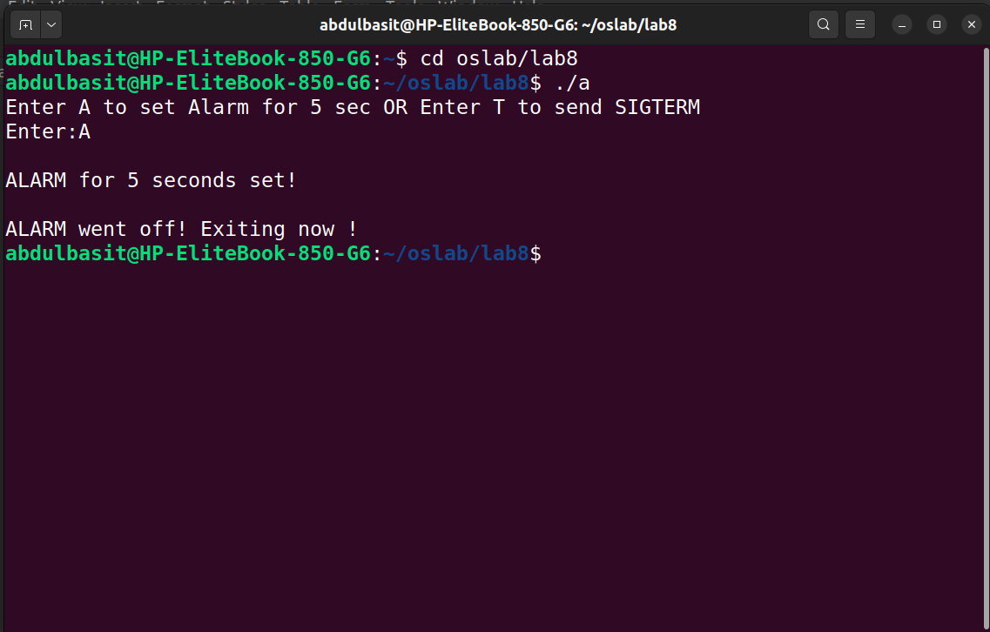

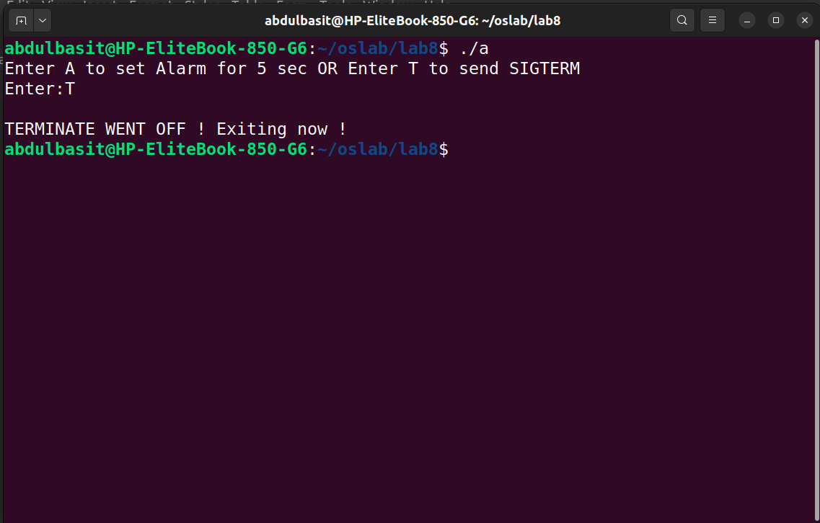
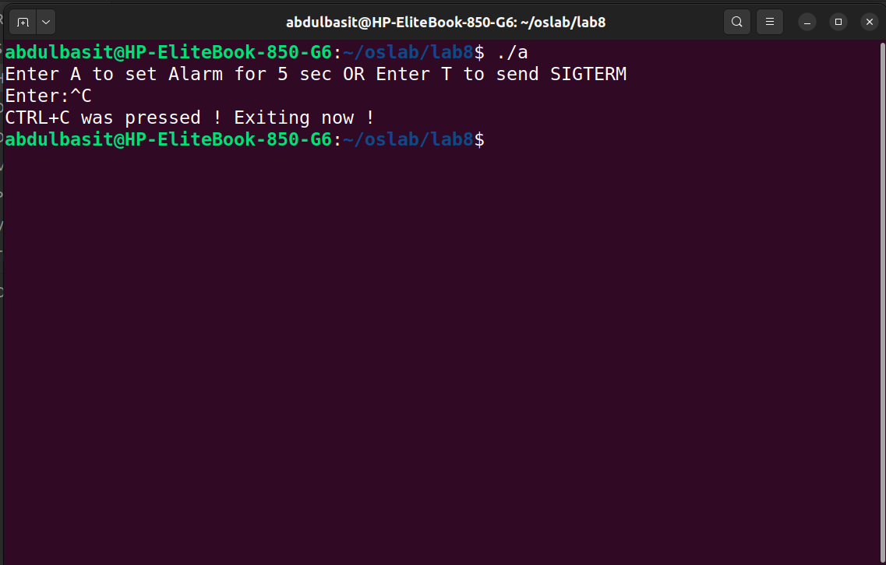

Q2:
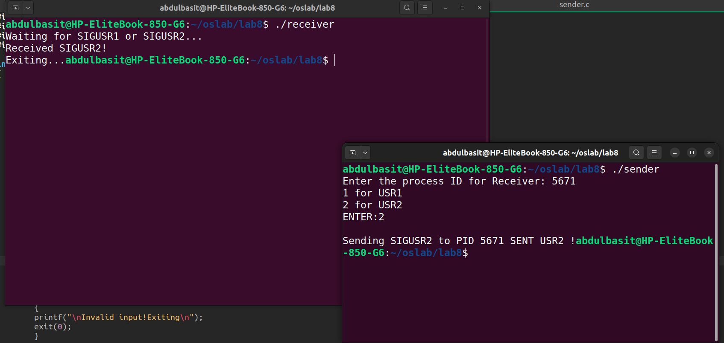
CODE:
SENDER:
#include <stdio.h>
#include <signal.h>
#include <unistd.h>
#include <stdlib.h>

int main ()
{
int PID;
int user;

printf("Enter the process ID for Receiver: ");
scanf("%d",&PID);

printf("1 for USR1\n2 for USR2\nENTER:");
scanf("%d",&user);

if(user==1)
{
printf("\nSending SIGUSR1 to PID %d \n",PID);
kill(PID,SIGUSR1);
printf("SENT USR1 !\n");
}
else if(user==2)
{
printf("\nSending SIGUSR2 to PID %d \n",PID);
kill(PID,SIGUSR2);
printf("SENT USR2 !\n");
}
else
{
printf("\nInvalid input!Exiting\n");
exit(0);
}

return 0;
}

RECIEVER:
#include <stdio.h>
#include <signal.h>
#include <unistd.h>
#include <stdlib.h>

void sigusr_handler(int sig)
{
if (sig == SIGUSR1)
{
printf("Received SIGUSR1!\n");

}
else if (sig == SIGUSR2)
{
printf("Received SIGUSR2!\n");
}

printf("Exiting...");
exit(0);

}

int main()
{
signal(SIGUSR1, sigusr_handler);
signal(SIGUSR2, sigusr_handler);

printf("Waiting for SIGUSR1 or SIGUSR2...\n");
pause();

return 0;
}

Q3:
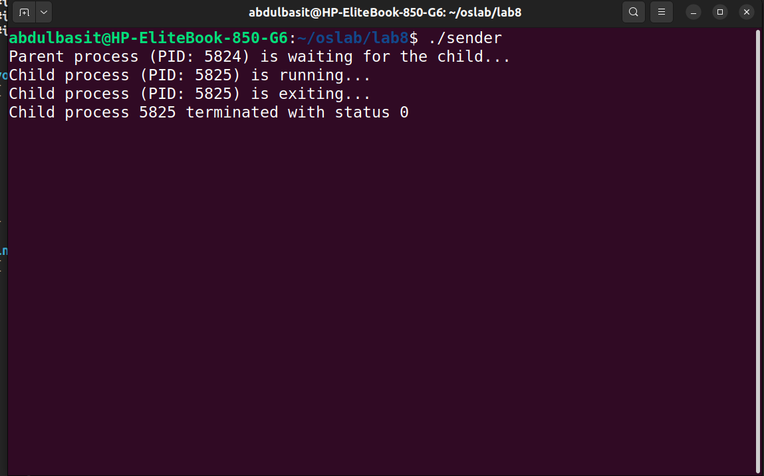
CODE;
#include <stdio.h>
#include <stdlib.h>
#include <unistd.h>
#include <signal.h>
#include <sys/wait.h>

void sigchld_handler(int sig)
{
int status;
pid_t pid;

pid = wait(&status);
if (pid > 0)
{
printf("Child process %d terminated with status %d\n", pid, WEXITSTATUS(status));
}
}

int main()
{
signal(SIGCHLD, sigchld_handler);

pid_t pid = fork();

if (pid == 0)
{

printf("Child process (PID: %d) is running...\n", getpid());
sleep(1);
printf("Child process (PID: %d) is exiting...\n", getpid());
exit(0);
}
else if (pid > 0)
{

printf("Parent process (PID: %d) is waiting for the child...\n", getpid());
while (1)
{
sleep(1);
}
}

return 0;
}

